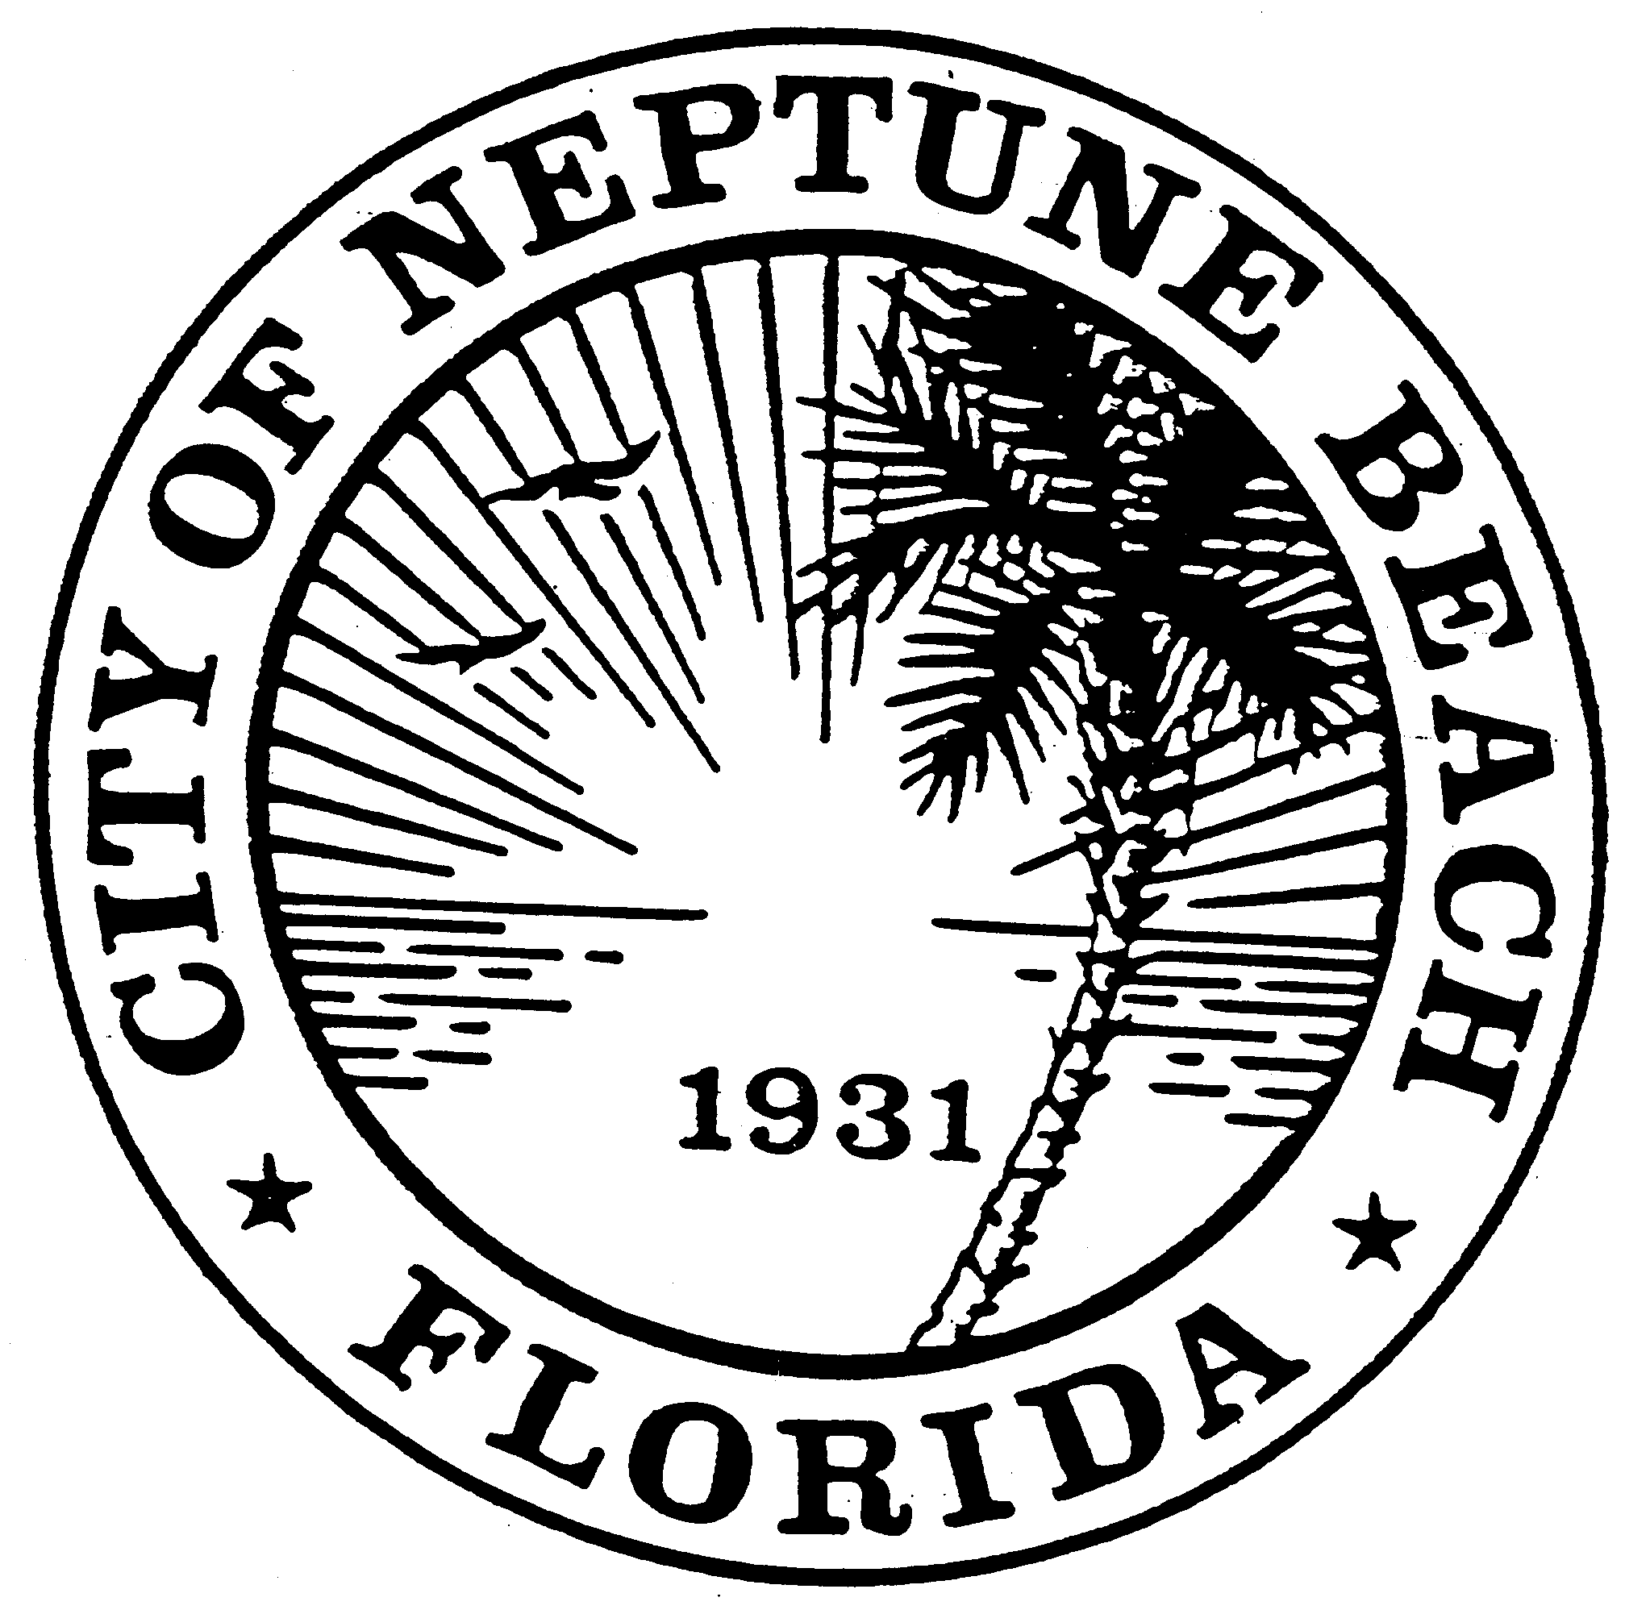

City of Neptune Beach
Planning and Community Development Department
116 First Street • Neptune Beach, Florida 32266-6140
(904) 270-2400 Ext. 36 • FAX (904) 270-2432

AGENDA

COMMUNITY DEVELOPMENT BOARD MEETING

NOVEMBER 4, 2020 AT 6:00 PM

116 FIRST STREET

NEPTUNE BEACH, FL 32266

- Call to Order.

- Approval of minutes for the October 14, 2020 meeting.

- CDB20-06 Application for Replat as outlined in Chapter 27, Article 3 of the Unified Land Development Code of Neptune Beach. The property is currently known as for 1004 and 1006-1008 First Street, (RE# 172840-0000 & 172842-0000). The subject property is located on the west side of First Street between Bay and Magnolia in the R-4 zoning district. The applicants are requesting to demolish the existing buildings and replat the properties into two conforming lots. The request is to remove 19 feet from the parcel know as 1006 First (RE#172842-00) and added it to the parcel 1004 First (RE#172840-0000). The granting of the replat would not create any additional lots.

- V20-05 Application for variance as outlined in Chapter 27, Article 8 of the Unified Land Development Code of Neptune Beach for Melinda Monti for the property known as 109 North Street (RE#173131-0000). The request is to vary section Table-27-229-1 for the front and east side yard and increase the floor area ratio and lot coverage to rebuild a single-family house with a 2nd story deck. Variance was previously granted to expand the non-conforming structure and add on in with the same footprint and setbacks as being requested.

- V20-06 Application for variance as outlined in Chapter 27, Article 3 Division 8 of the Unified Land Development Code of Neptune Beach for Connor Family Trust for the property known as 2110 First Street (RE#173749-5000). The request is to vary Table 27-229-1-Rear and side yard setback to enclose the existing carport.

- V20-07 Application for variance as outlined in Chapter 27, Article 3 Division 8 of the Unified Land Development Code of Neptune Beach for 1414 NB, LLC for the property known as 1414 First Street (RE#173027-0000). The request is to vary Table 27-229-1 side yard setback to build a new single-family dwelling.

- V20-10 Application for variance as outlined in Chapter 27, Article 3 Division 8 of the Unified Land Development Code of Neptune Beach for Anne Cruddas for the property known as 601 Bowles Street (RE#173403-0064). The request is to vary Table 27-229-1-Rear setback to build an addition on the rear of the house.

- V20-11 Application for variance as outlined in Chapter 27, Article 3 Division 8 of the Unified Land Development Code of Neptune Beach for Kerry & Renee Mowlam for the property known as 224-226 Oleander Street (RE#173492-0000). The request is to vary section 27-328(a)(3)-Other Accessory Structures to build a 14-foot tall detached garage with vertical exterior wall height to exceed eight feet.

- Open Discussion.

- Adjourn.

