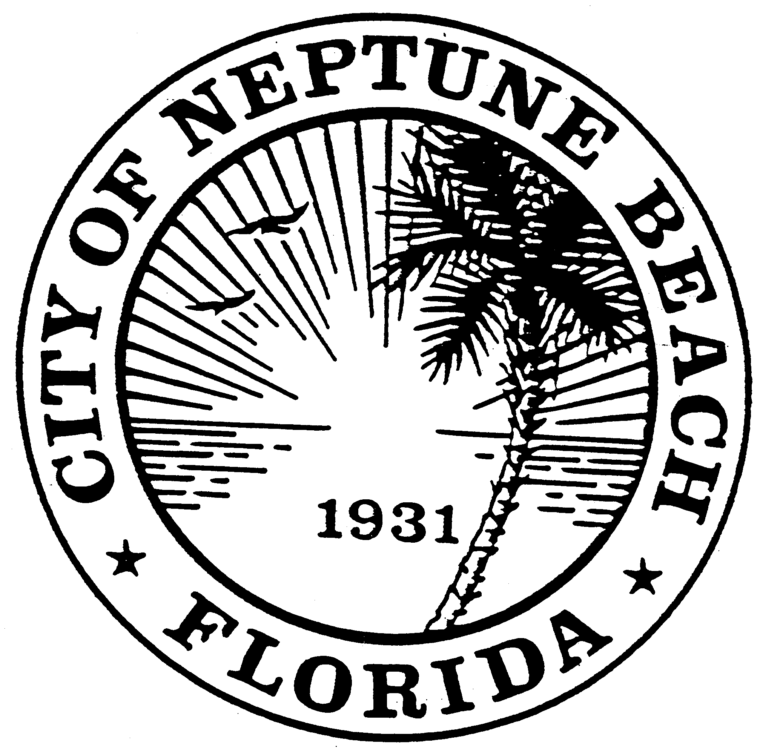

City of Neptune Beach
Planning and Community Development Department
116 First Street • Neptune Beach, Florida 32266-6140
(904) 270-2400 Ext. 34

AGENDA

COMMUNITY DEVELOPMENT BOARD MEETING

NOVEMBER 10, 2021 AT 6:00 PM

116 FIRST STREET

NEPTUNE BEACH, FL 32266

- Call to Order.
- Approval of October 13, 2021 minutes.
- SE21-04 Application for a new special exception to modify the outdoor dining as outlined in Chapter 27, Article 3 Division 9 of the United Land Development Code for MNCW, LLC for the property known as 1455 Atlantic Blvd. The request is to build an awning type structure to cover the existing outdoor seating. The original special exception for outdoor dining was granted on October 1, 2012. No additional seating capacity is being requested.

- Open Discussion.

- Adjournment

