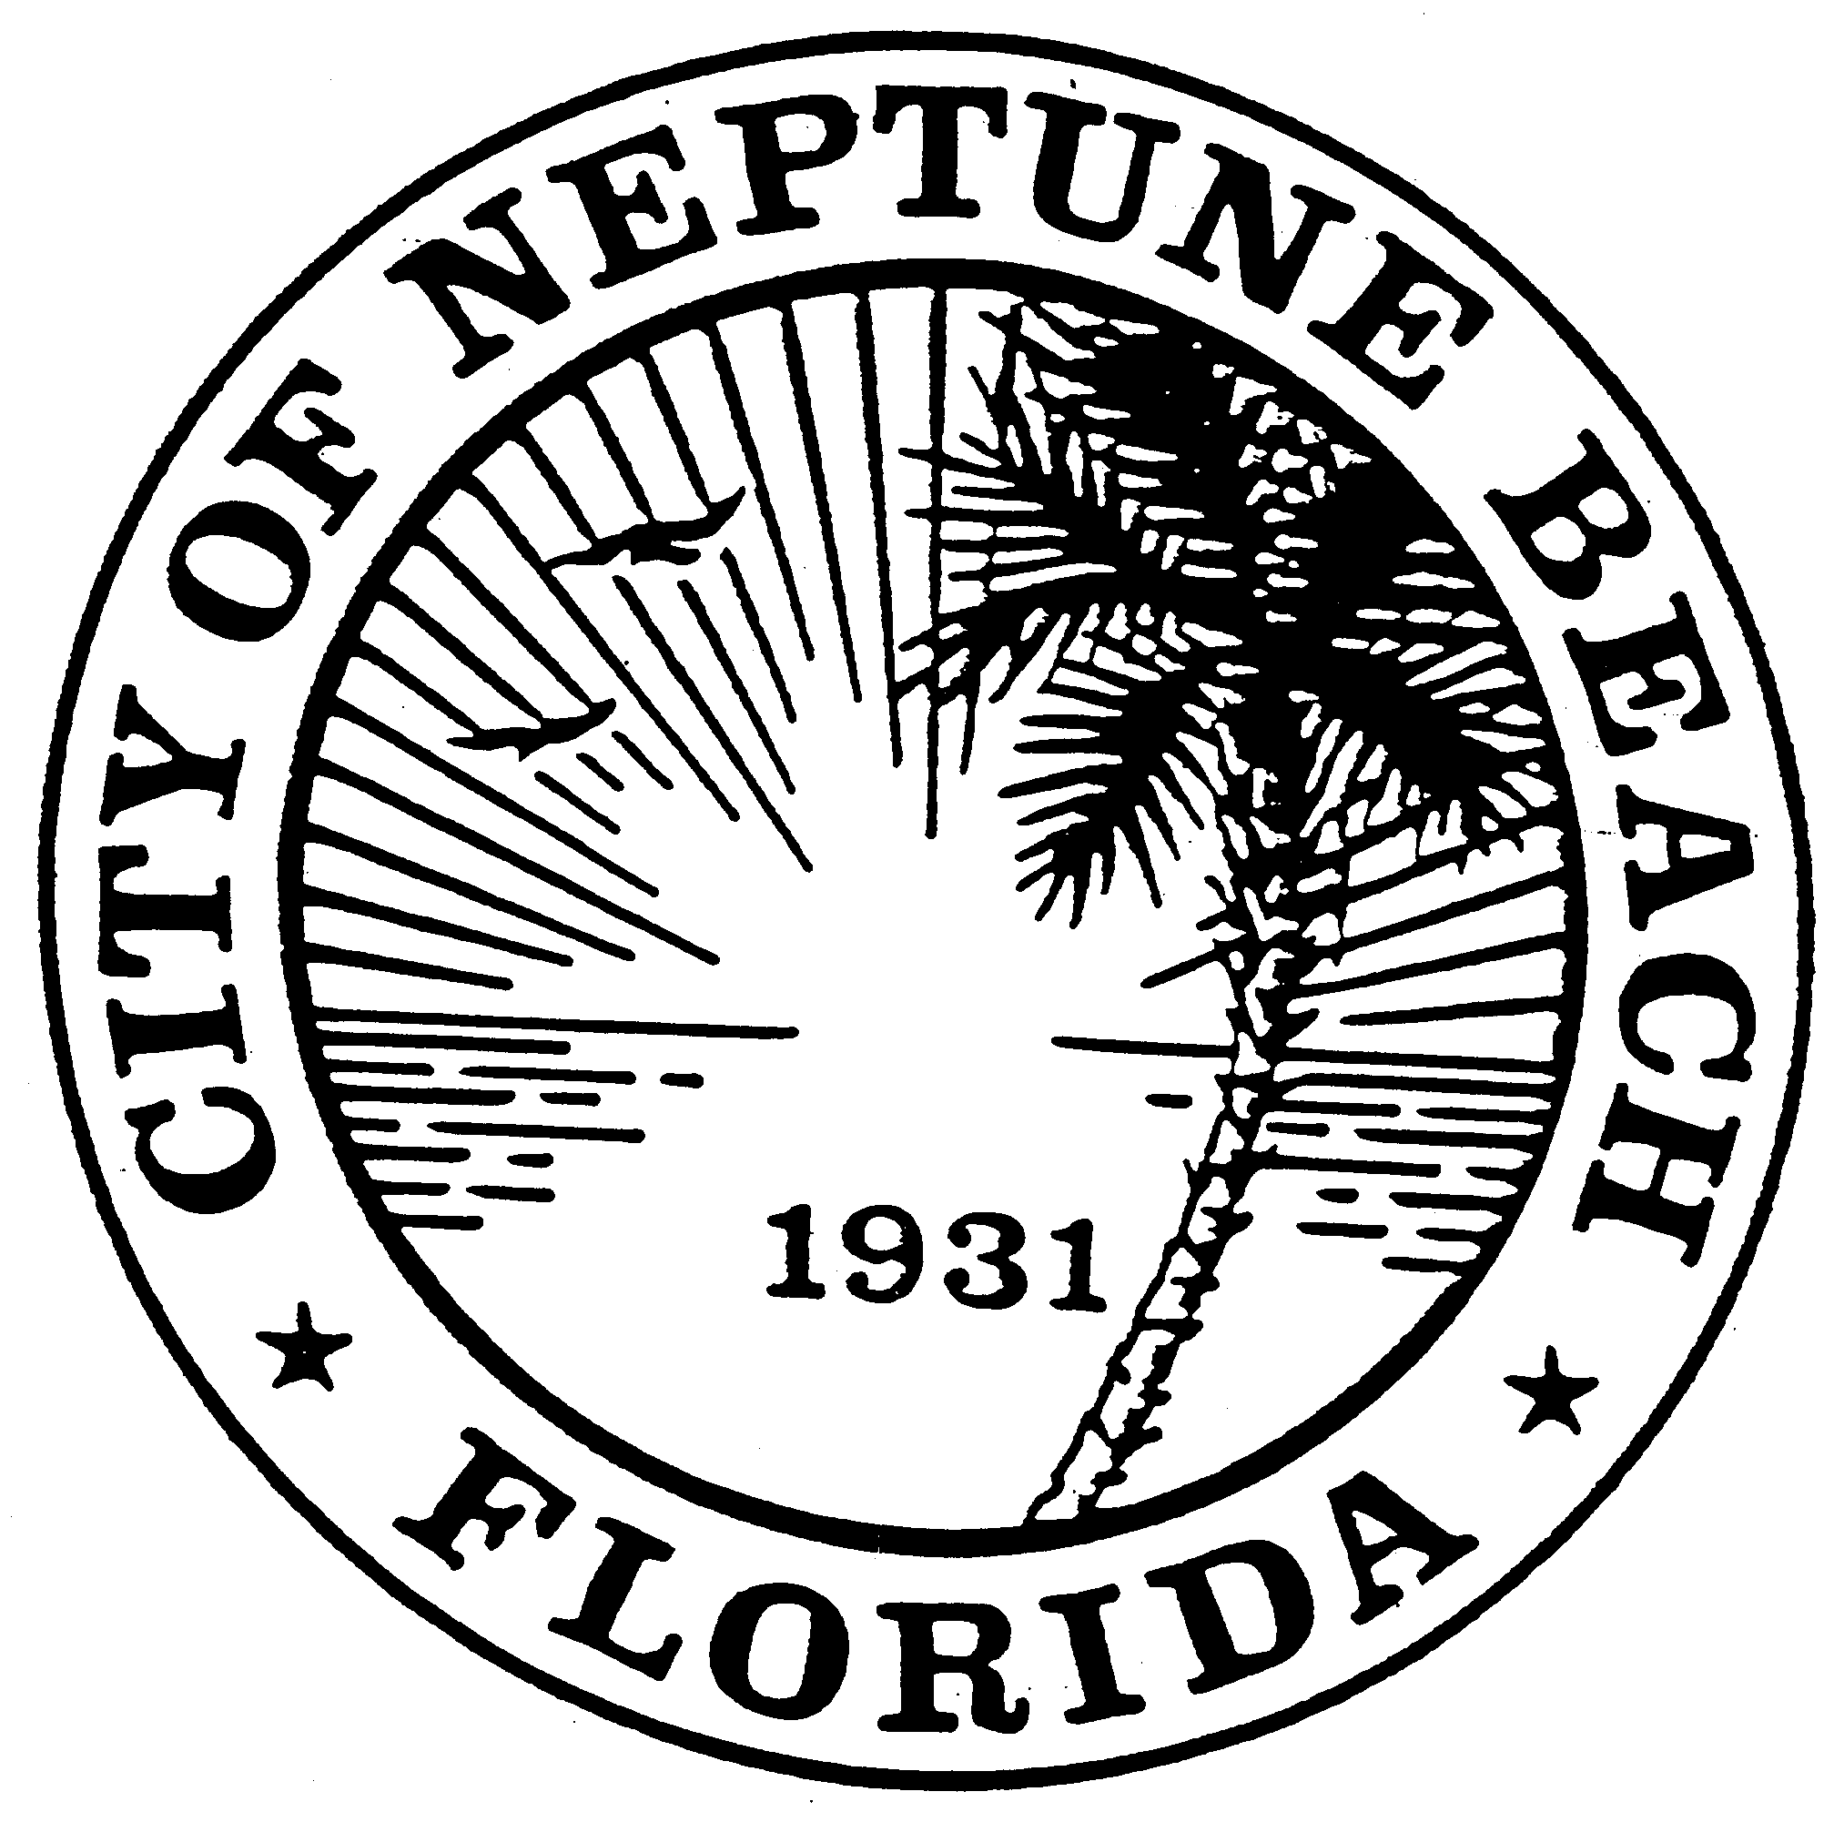

City of Neptune Beach
Planning and Community Development Department
116 First Street • Neptune Beach, Florida 32266-6140
(904) 270-2400 Ext. 34

AGENDA

COMMUNITY DEVELOPMENT BOARD MEETING

SEPTEMBER 22, 2021 AT 6:00 PM

116 FIRST STREET

NEPTUNE BEACH, FL 32266

- Call to Order.
- V21-10 Application for variance as outlined in Chapter 27, Article III Division 8 of the Unified Land Development Code of Neptune Beach for Eric W. Mott for the property known as 100 Lora Street and 1632 Strand (RE#173099-0000). The request is to vary section 27-238(4) and Table 27-229-1 The request is to expand the second story balcony on the east side of an existing duplex structure.

- V21-11 Application for variance as outlined in Chapter 27, Article III Division 8 of the Unified Land Development Code of Neptune Beach for Robert G. Burt for the property known as 311 First Street (RE#172755-0500). The request is to vary section 27-238 (4) and Table 27-229-1. The request is to replace concrete driveway with permeable pavers. Previous variance to exceed maximum lot coverage was granted in 2012.

- Open Discussion.

- Adjournment

