 |  | 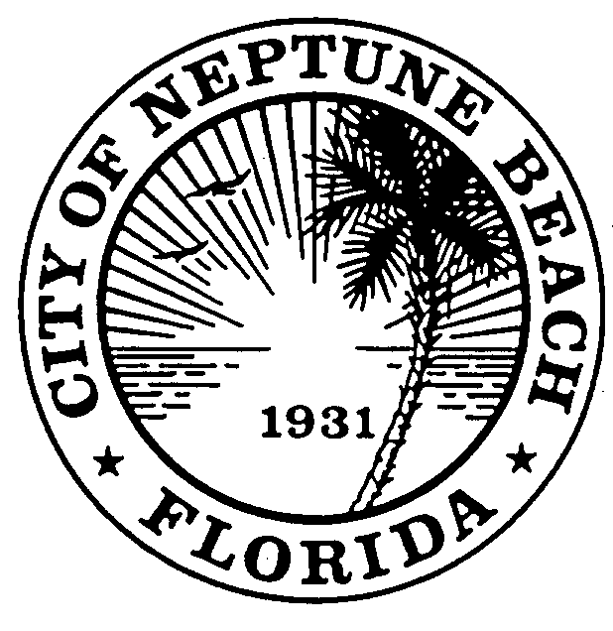
MINUTES
COMMUNITY DEVELOPMENT BOARD
AUGUST 12, 2020 AT 6:00 P.M.
COUNCIL CHAMBERS
116 FIRST STREET
NEPTUNE BEACH, FLORIDA 32266

 |  | Pursuant to proper notice a public hearing of the Community Development Board for the City of Neptune Beach was held meeting by Communications Media Technology on August 12, 2020 at 6:00 p.m. via the internet.
Attendance |  | Board members were in attendance:  Christopher Goodin, Chair  Ryan Dill, Vice-Chair  Charley Miller, Member  W. Jeremy Randolph, Member  Nia Livingston, Member  David Jaffee, Alternate Member  Jonathan Raiti, Alternate Member  Greg Schwartzenberger, Alternate Member
The following staff members were present:
Stefan Wynn, City Manager
Zachary Roth, City Attorney
Kristina Wright, Community Development Director
Piper Turner, Code Compliance Supervisor
Call to Order/Roll Call |  | Chair Goodin called the meeting to order at 6:02 p.m. V20-01 for the former Lucky’s Market has requested to delay their application,
Disclosure of  ex-parte communications |  | Several members disclosed that they had spoken with the owner of the Local restaurant.
Minutes |  | Made by Randolph, seconded by Dill.
MOTION: | TO APPROVE THE JULY 8 AND JULY 15, 2020 MINUTES AS SUBMITTED.
All in favor.
MOTION CARRIED

Swearing in | Mr. Roth asked anyone appearing before the board to raise their right hand to be sworn in.
CDB 20-02  Art Project  301 Atlantic Blvd | Kristina Wright, Community Development Director gave her staff report and recommendation. Application CDB 20-02 301 Atlantic Boulevard is a request for an art project as outlined in Chapter 27, Sec. 27-596 of the Unified Land Development Code for the property known as 301 Atlantic Boulevard (PIN: 172982-0000) and the dumpster enclosure that is located on the City’s right-of-way on Second Street adjacent to 301 Atlantic Boulevard. The property is owned by Huron Sophia, LLC and is occupied by The Local Restaurant. The request is to paint a mural on the eastern wall of the building and paint the dumpster enclosure to match. The property is zoned Commercial Business District.  According to Sec. 27-596: Any proposed art project in the commercial districts that in the opinion of a majority of the community development board is found to be public art that enhances the commercial district may be recommended to the City Council for its approval. If approved by the City Council, such an art project will be permitted as long as it is maintained in good condition. The City Council may place conditions for approval on the proposed project. Any such art project which deteriorates over time shall be removed by the applicant at the sole discretion of the City Council.  Sec. 27-596 also indicates that both the Community Development Board and the City Council shall determine the following: That the proposed art project will enhance the aesthetic beauty of the area of its proposed location:  The applicant is proposing a spray-painted mural on the eastern side of the building and dumpster that is approximately 43 feet x 14 feet. The applicant has indicated that they are seeking to enhance the aesthetic beauty of the surrounding area with this mural by bringing a “pop of color” on the large blank wall along Second Street.  - That the artist is capable of completing the work in accordance with the plan submitted as part of the application:  The applicant is using a well-known, local company, Artistic Finishes, to complete the work. The applicant has indicated that the project will require an additional 2 to 3 days to complete.  - That the information in the application regarding the durability and expected maintenance of the proposed art project is correct:  Durability is being addressed through the use of a heavy-duty exterior spray paint.  - That the materials to be used and the manner of application will not require excessive maintenance by its owner:  The local artist will be available for any touch-ups if these are ever necessary.  Staff recommends approval of CDB 20-02 301 Atlantic Boulevard to the City Council.
 | Jack Demetree, representing property owner Huron Sophia, LLC, state he was available for any questions. No questions or comments were presented.
 | Public hearing was opened for comments there being none, public comments was closed.
 | Made by Livingston, seconded by Jaffee.
MOTION: |  |  | MOVE TO RECOMMEND APPROVAL OF CDB 20-02 TO CITY COUNCIL FOR AN ART PROJECT AT 301 ATLANTIC BLVD.
 | ROLL CALL:
 | AYES |  |  | 7-Jaffee, Raiti, Miller, Livingston, Randolph, Dill, Goodin
 | NOES |  |  | 0
 | MOTION APPROVED.
The applicants were informed their request was approved and that the application would be forwarded to City Council for final review at their next regular meeting.
Adjournment |  | There being no further business, the meeting adjourned at 6:20 p.m.
 |  |  |  | Chairperson Christopher Goodin
ATTEST:

Piper Turner, Board Secretary

