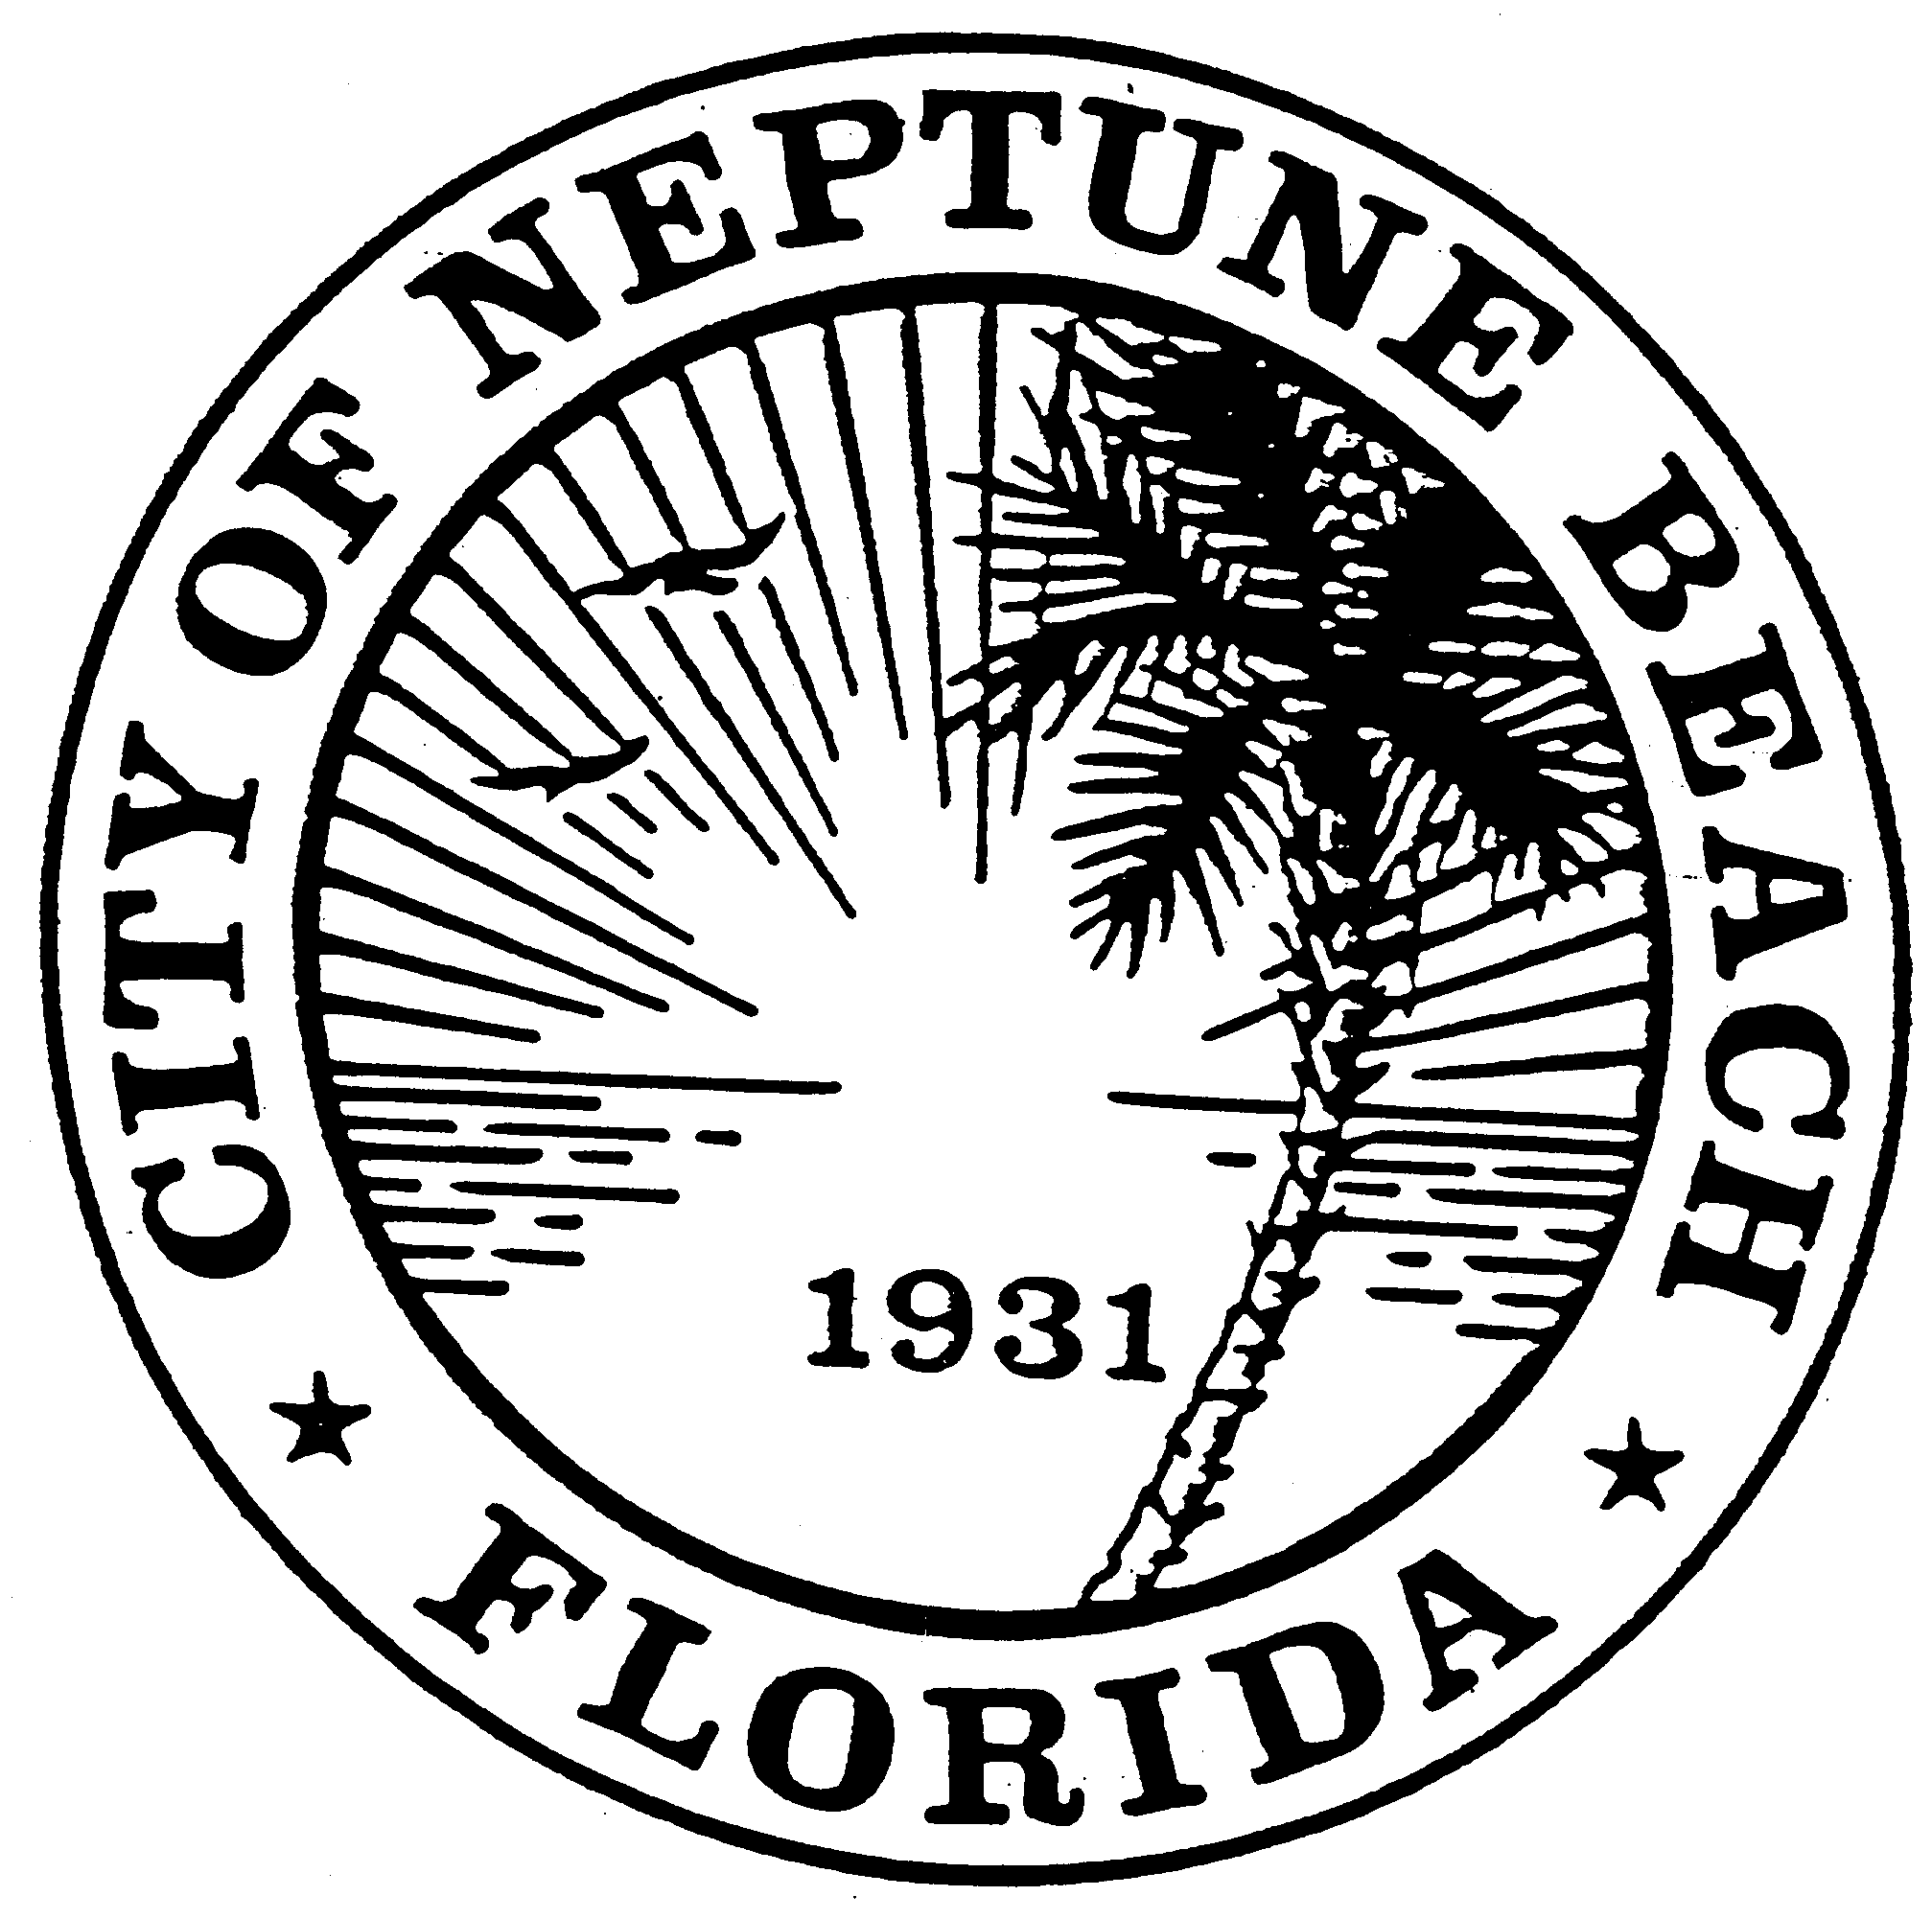

City of Neptune Beach
Community Development Department
116 First Street • Neptune Beach, Florida 32266-6140
(904) 270-2400 Ext. 34 CDD@NBFL.US

AGENDA

COMMUNITY DEVELOPMENT BOARD MEETING

FEBRUARY 8, 2023 AT 6:00 PM

116 FIRST STREET

NEPTUNE BEACH, FL 32266

- Call to Order and roll call.

- Pledge of Allegiance.

- Approval of the Oct. 22, 2022 and January 11, 2023 minutes.

- V23-04 Application for variance as outlined in Chapter 27 Article III Division 8 of the Unified Land Development Code of Neptune Beach for Ian and Jessica Otto, for the property known as 428 south Street (172697-0000). The request is to vary Table 27-239 for the east side yard (request of 2 ft 8 inches leaving 4 ft 3 in in lieu of the required 7.1 ft east side yard). The request for variance is to build an addition following the same setback as the existing home. (Tabled at the Jan. meeting).

- SE23-01 Application for a special exception as outline in Chaper 27 Article 3 Division 9 of the United Land Development Code for Margaret R. Driver for the property formerly known as 108 Orange Street (Parcel #172769-0000). The request for special exception is to build a new single-family dwelling in the Central Business District (CBD).

- V23-06 Application for variance as outlined in Chapter 27 Article III Division 8 of the Unified Land Development Code of Neptune Beach for Adam Rigel, for the properties formerly known as 1006 and 1020 First Street (RE# 172689-0000 & 172838-000). The requests are to vary Table 27-239 Maximum Lot Area by combining the two parcels. The request of 201.9 square feet, leaving 15,201.9 square feet in lieu of the maximum 15,000 square feet. The request for variance is to build a single-family dwelling once the parcels are combined.

- Open Discussion.

- Adjourn.

PARKING CODE THROUGH APRIL 1ST: HX12

