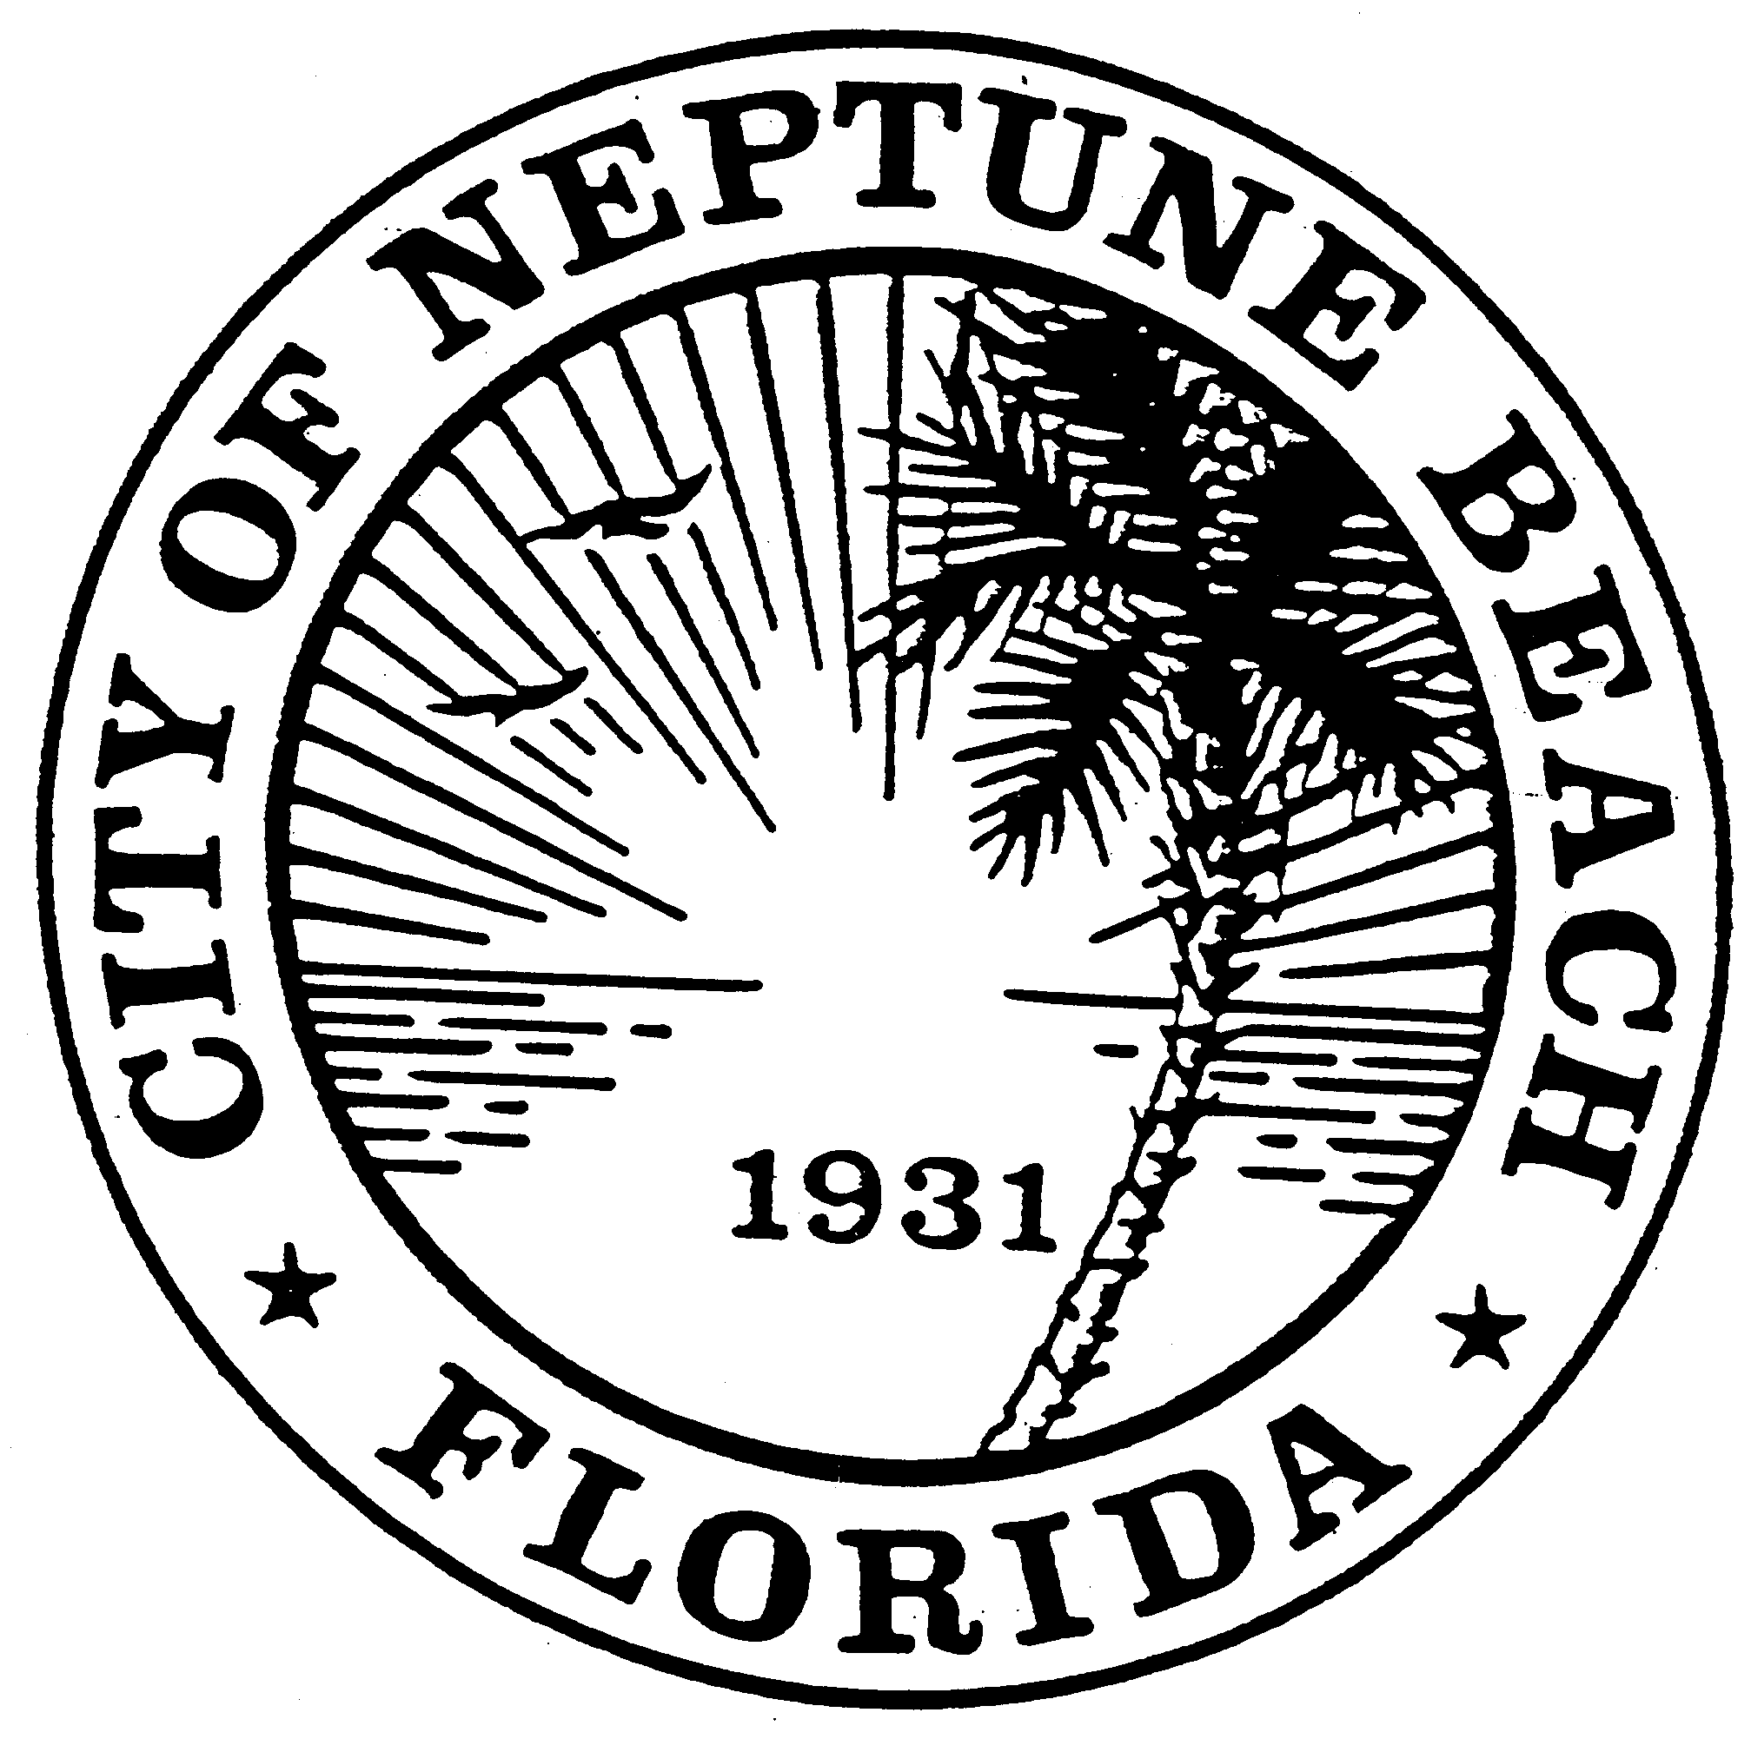

City of Neptune Beach
Planning and Community Development Department
116 First Street • Neptune Beach, Florida 32266-6140
(904) 270-2400 Ext. 36 • FAX (904) 270-2432

AGENDA

(REVISED)

COMMUNITY DEVELOPMENT BOARD MEETING

AUGUST 12, 2020 AT 6:00 PM

116 FIRST STREET

NEPTUNE BEACH, FL 32266

- Call to Order.

- Approval of the July 8 and July 15, 2020 minutes.

- V20-01 Application for variance as outlined in Chapter 27, Article 8 of the Unified Land Development Code of Neptune Beach for Neptune Beach Fl Realty, LLC for the property known as 540-580 Atlantic Blvd (RE#172395-0130). This property is former Lucky’s Market in the Neptune Beach Plaza. The variance request is to provide relief from Note 6 of Table 27-229-1 by varying the 1000 linear foot requirement for businesses that operate under common business ownership or management, share a warehouse or distribution facility, or otherwise operate as an associated, integrated or cooperative business shall not exceed a combined sixty thousand (60,000) square feet of total gross floor area in aggregate.

- CDB20-02 Application for an Art Project as outlined in Chapter 27 Sec. 27-596 of the Unified Land Development Code for the property known as 301 Atlantic Blvd (Re#172982-0000) and the dumpster enclosure that is located on the City’s right of way of Second Street adjacent to 301 Atlantic. The property is owned by Huron Sophia, LLC and is occupied The Local restaurant. The request is to paint a mural on the eastern wall of the building and paint the dumpster enclosure to match.

- Open Discussion.
- Adjourn.

INSTRUCTIONS FOR THE AUGUST 12, 2020 AT 6:00 PM NEPTUNE BEACH HYBRID COMMUNITY DEVELOPMENT REVIEW BOARD MEETING

This meeting will be a hybrid in-person and a webinar conducted electronically meeting. Space for the in-person meeting will be limited due to social distancing requirements. The webinar portion will be conducted as permitted in Governor Executive Order No. 20-69 and extended by Governor Executive Order 20-112. The City has adopted Emergency Rules Regarding to COVID-19 to Govern the Operation of Meetings of the City Council and Board of the City of Neptune Beach, which will also govern the webinar portion. Such rules are available from the City Clerk.

Registered webinar participants can also share comments live during the meeting; you must request to do this using the “raise your hand” feature during “Comments from the Public” portion of the meeting.

The meeting can be observed in the following ways: You may register to attend the GoToWebinar and view the meeting on your computer or dial in and listen on your telephone by visiting the following link:

https://attendee.gotowebinar.com/register/8236963180726899979
TO USE YOUR COMPUTER'S AUDIO:
When the webinar begins, you will be connected to audio using your computer's microphone and speakers (VoIP). A headset is recommended. --OR-- TO USE YOUR TELEPHONE: If you prefer to use your phone, you must select "Use Telephone" after joining the webinar and call in using the numbers below.
United States: +1 (415) 655-0052 Access Code: 576-757-585

Audio PIN: Shown after joining the webinar Webinar ID: 255-872-931

