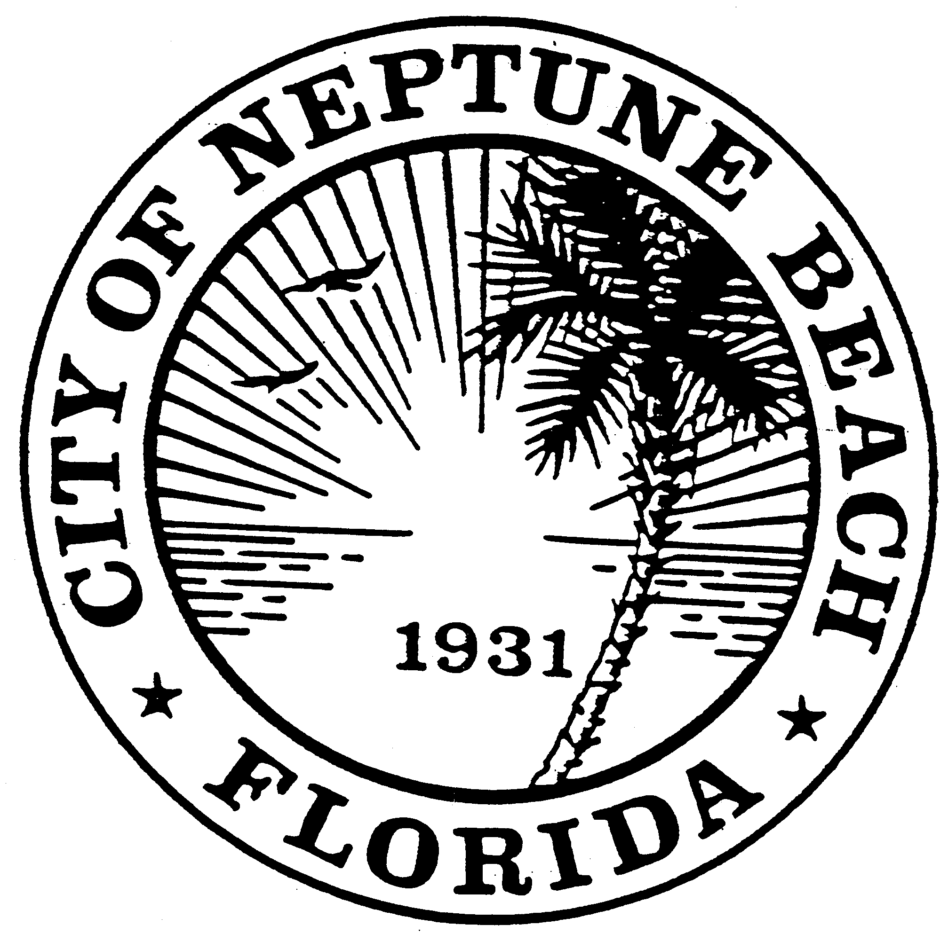

City of Neptune Beach
Planning and Community Development Department
116 First Street • Neptune Beach, Florida 32266-6140
(904) 270-2400 Ext. 34

AGENDA

COMMUNITY DEVELOPMENT BOARD MEETING

OCTOBER 13, 2021 AT 6:00 PM

116 FIRST STREET

NEPTUNE BEACH, FL 32266

- Call to Order.
- Approval of July 14, 2021 minutes.
- SE21-01 Application for special exception for outdoor dining as outlined in chapter 27, Article 3 of the United Land Development Code for 218 First Street, LLC and Slider’s restaurant. The request is to create an accessible outdoor seating area on the east side of the existing building and associated landscaping. No additional seating capacity is being requested.

- CDB21-03 Pursuant to the approval of SE21-01 an application for Preliminary Development Order for a restaurant as outlined in Chapter 27, Article 3 of the Unified Land Development Code for 218 First Street, LLC. The property is currently known as 218 First St. The request is to remove the existing windows on the east elevation and replace with two garage style doors and mounting a bar top for outdoor seating. Replacement of the wall mounted sign with a new one. No increase in outdoor seating capacity.

- Open Discussion.

- Adjournment

