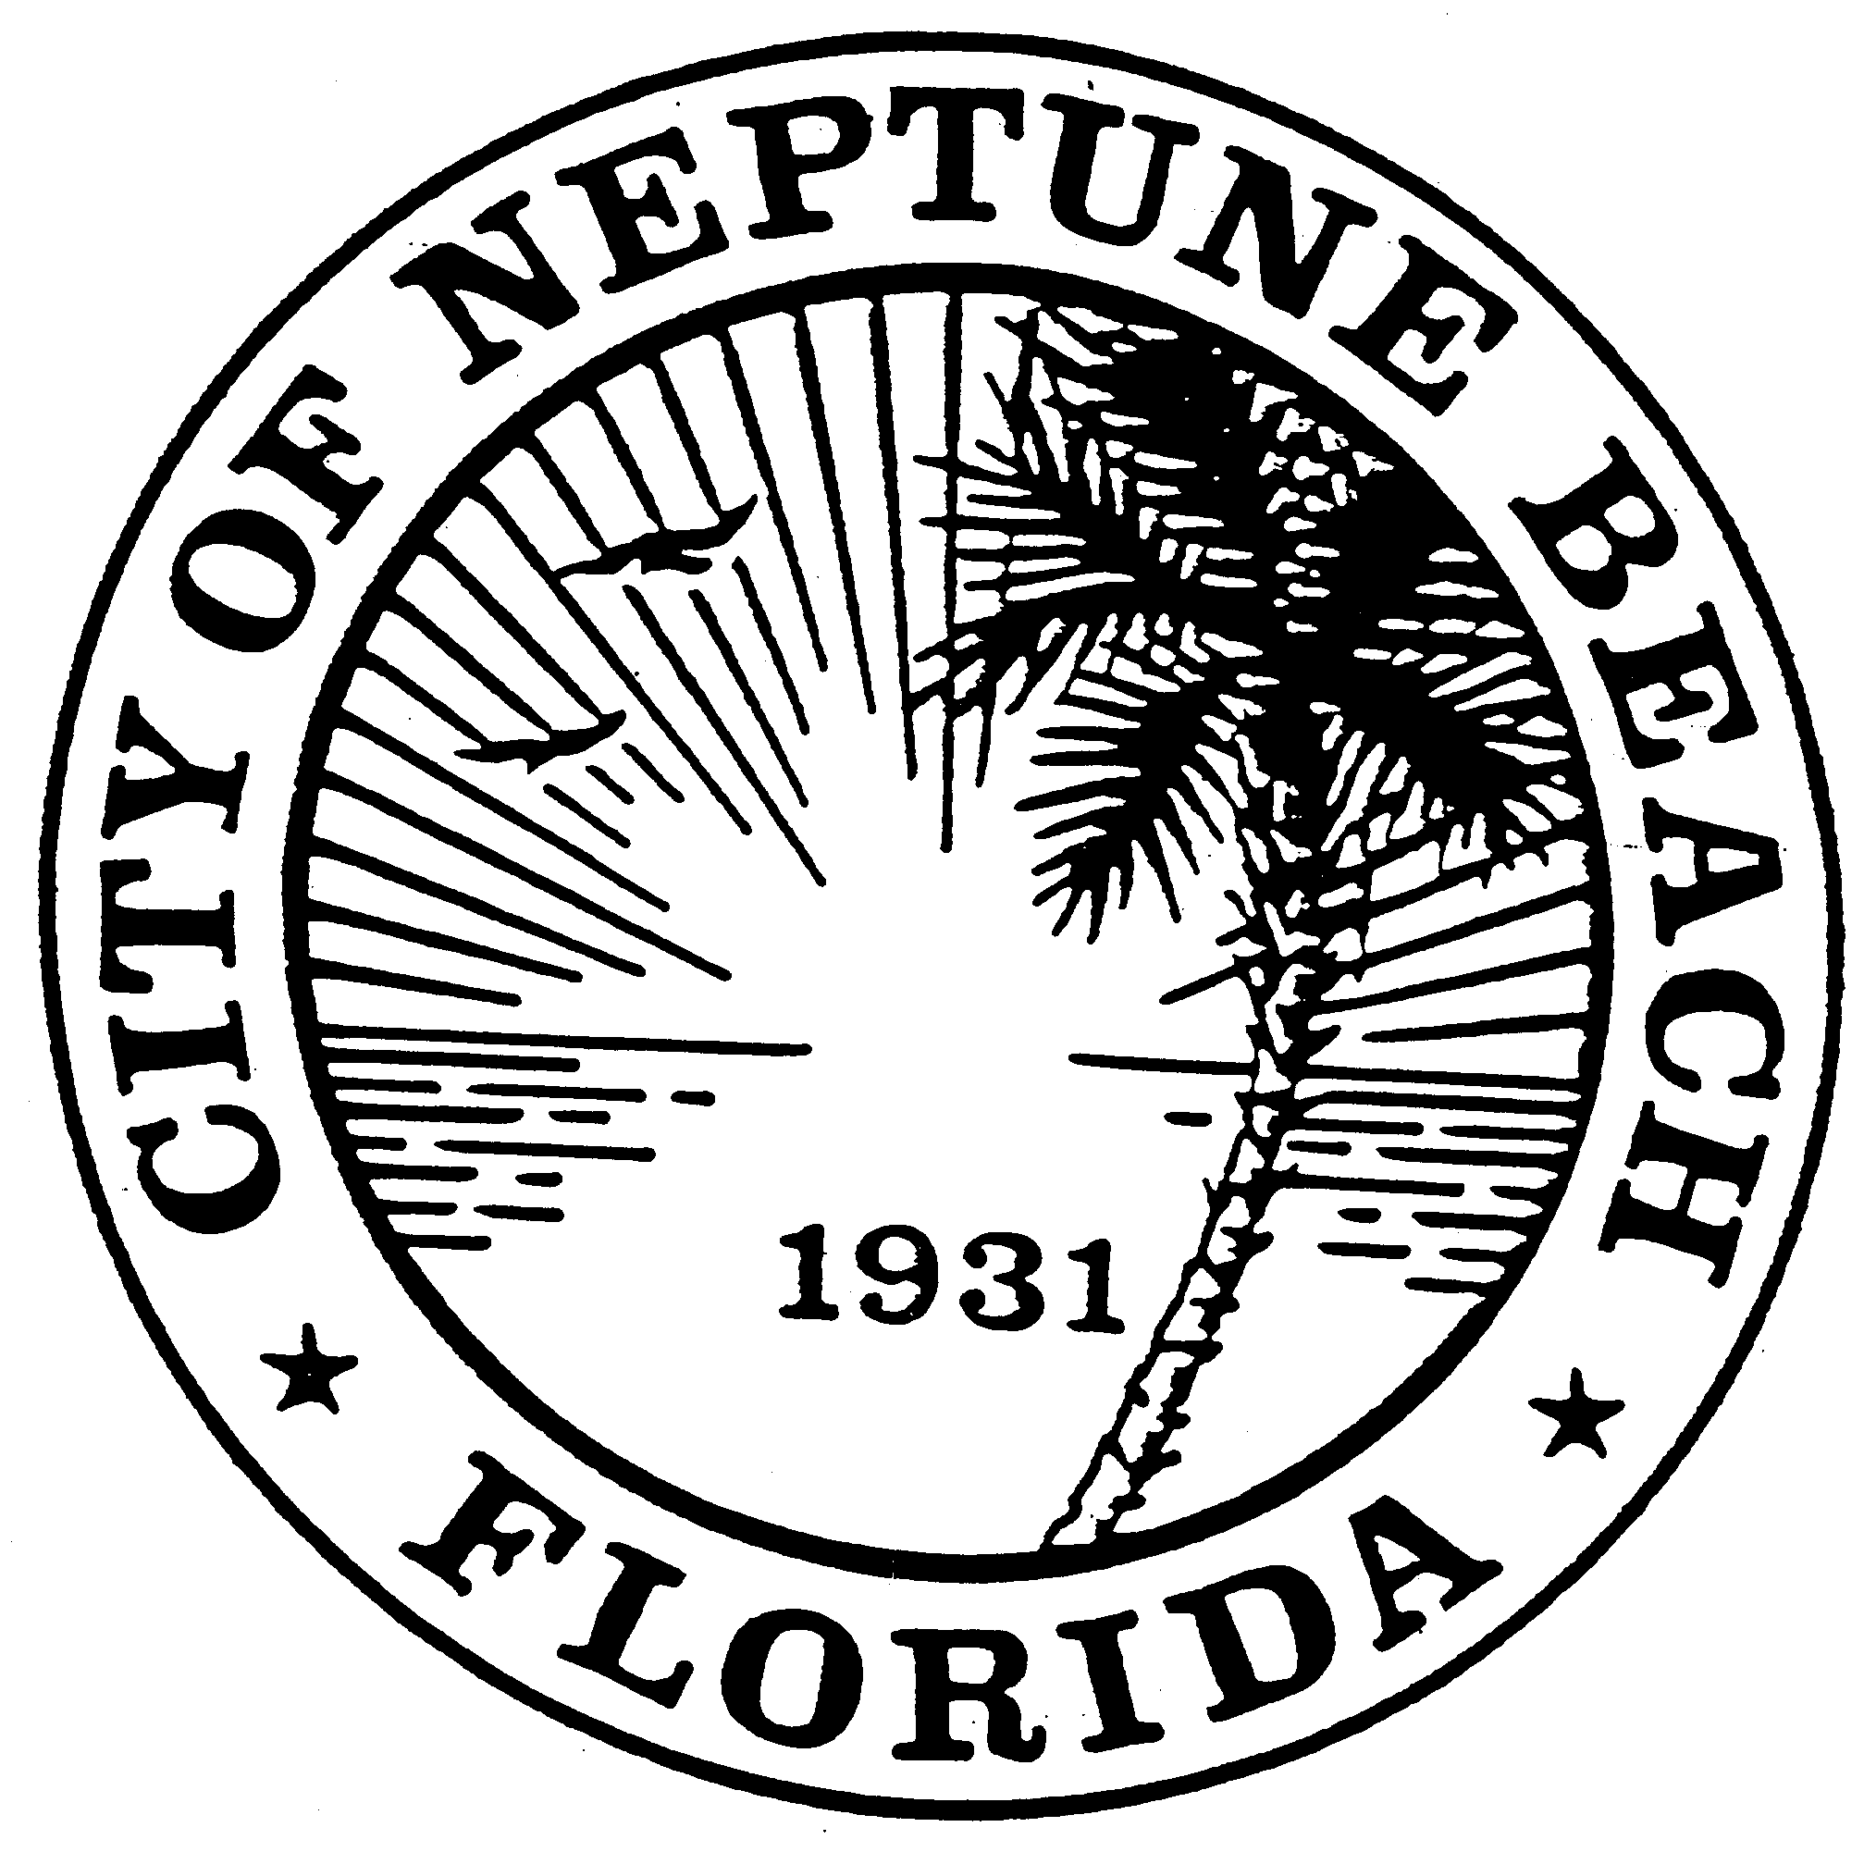

City of Neptune Beach
Planning and Community Development Department
116 First Street • Neptune Beach, Florida 32266-6140
(904) 270-2400 Ext. 36 • FAX (904) 270-2432

AGENDA

COMMUNITY DEVELOPMENT BOARD MEETING

NOVEMBER 13, 2019

CITY COUNCIL CHAMBERS

116 FIRST STREET

NEPTUNE BEACH, FL 32266

- Call to Order and Roll Call.

- Disclosure of ex-parte communications.

- Approval of October 9, 2019 minutes.

- CDB 19-11 Application for Development Permit review as outlined in Chapter 27, Article 2 of the Unified Land Development Code of Neptune Beach for Brewhound Coffee Bar Company for the property known as1848 Kings Circle South (RE# 173290-0000). This property is in the C-2 zoning district. The applicant is proposing to build an 8’ by 8’ accessory structure to serve as a Kiosk for customer check-in and reception.

- CDB 19-012 Application for Replat as outlined in Chapter 27, Article 3 of the Unified Land Development Code of Neptune Beach for 324 Myrtle Street, LLC. The property is currently known as 324 Myrtle Street, (RE# 172976-0000). The subject property is located on the northeast corner of Third and Myrtle Streets. The applicants are requesting to demolish the existing duplex and subdivide the property into two conforming lots that will front on Myrtle Street.

- Open Discussion.
- Adjourn.

